**CHAPTER 2. Communication and networking technologies**

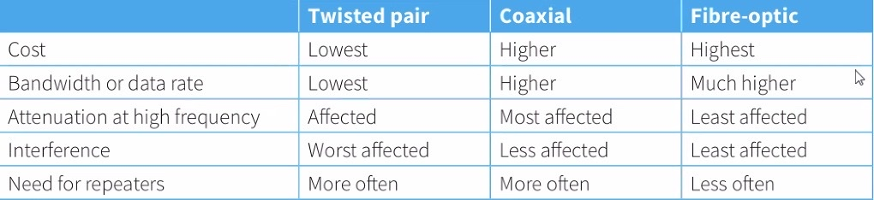

Fibre-optic cables can break when bent

modem 调制解调器

1.光转数字

2.Public switched telephone network(PSTN)

模拟转数字

The PSTN consists of many different types of communication lines

Data is transmitted in both directions at the same time

(full) duplex data transmission

The communication passes through different switching centres

wireless:

free to move

support more connections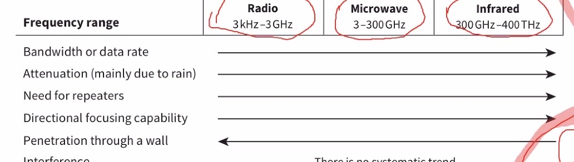

more interferencce

ELECTROMAGNET WAVE=WIRELESS

LEO-low-Earth-orbit

MEO-GPS-global positioning system

GEO-geostationary Earth orbit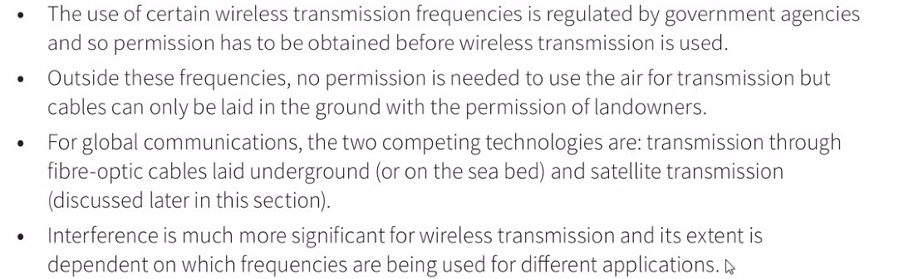

mesh topology

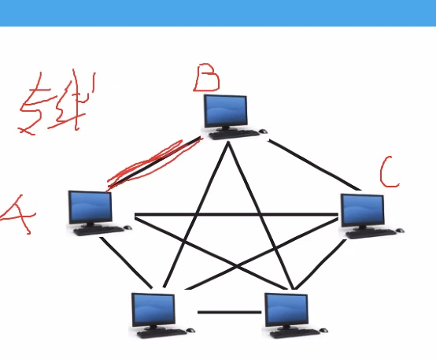

bus topology

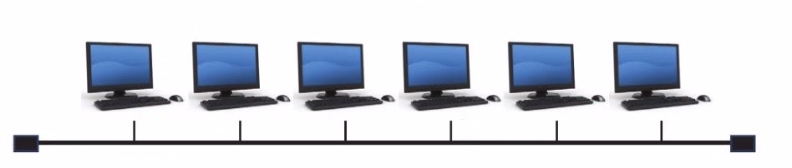

star topology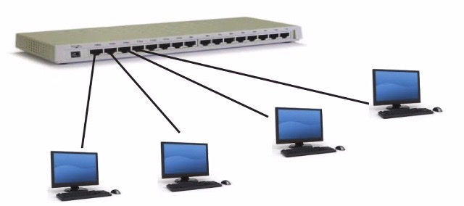

switch 交换机

youter 路由器--assign ip address to devices

--devide to data packet 数据包

transmit and receive data packet

hub 集线器--广播

CSMA/CD - Carrier Sense Multiple Access/Collison Detection

MEANING - A workstation/node (wishing to transmit) listens to the communication channel

data is only sent when the channel is free

two workstation can start to transmit at the same time, causing a collision

if a collisioon happens, the workstations send a (jamming) signal/abort transmition

each waits a random amount of time before attempting to resend

Hybrid network/topology 混合TOP

Bandwidth - 带宽

local area network (LAN) 局域网

metropolitan network (MAN) 城域网

wide area network (WAN) 广域网

Internet 因特网

World Wide Web (WWW) - 万维网

World Wide Web (WWW) is a distributed application which is available on the Internet

The internet infrastructure

Internet Service Provider (ISP)

Stream media

1. On-demand
2. Real-time

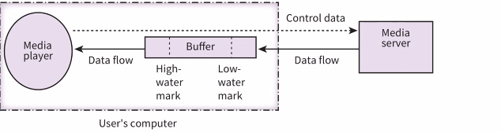

buffer:deal with transfer speed mismatch problem

Cloud computing

* infrastructure provision
* platform provision
* software provision

private cloud: owned by and only accessed by an organisation

public cloud: owned by a cloud service provider for general access

server farm: 服务器集群

IPv4:

IPv4 32 bits, written in 4 parts seperated by dots, each part within 0 to 255, written in denary

public:the address can be reached over the Internet

private:the address is more secure

the address can only be accessed through the same LAN

the address can be duplicated in different networks

IPv6 128 bits, written in eight parts, each part written in hexadecimal characters, seperated by colon

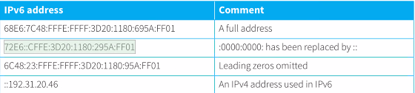

NAT

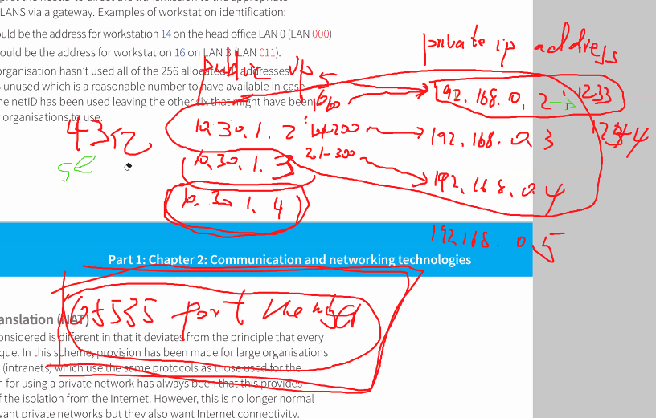

PRIVATE IP ADDRESS:192.168.[ ].[ ]

Sub net :

advantages:

[1.More](http://1.More) efficient to the INTERNET

[2.REDUCE](http://2.REDUCE) LATENCY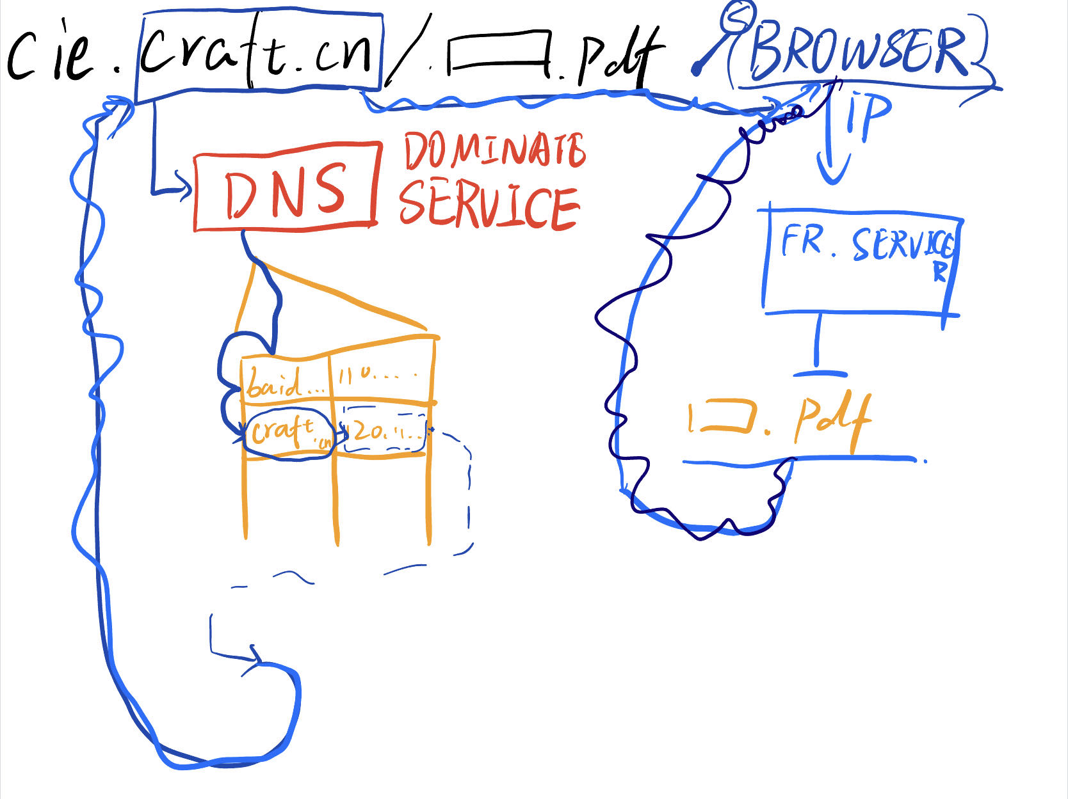

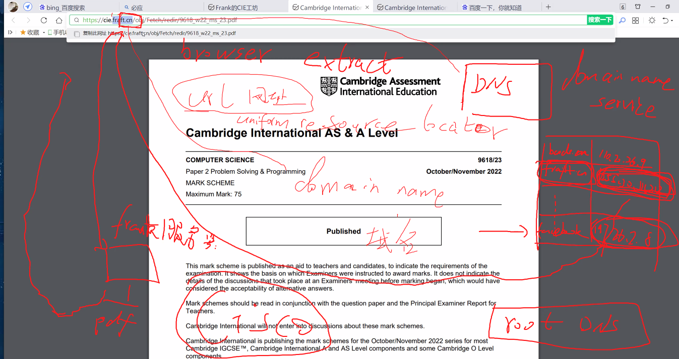

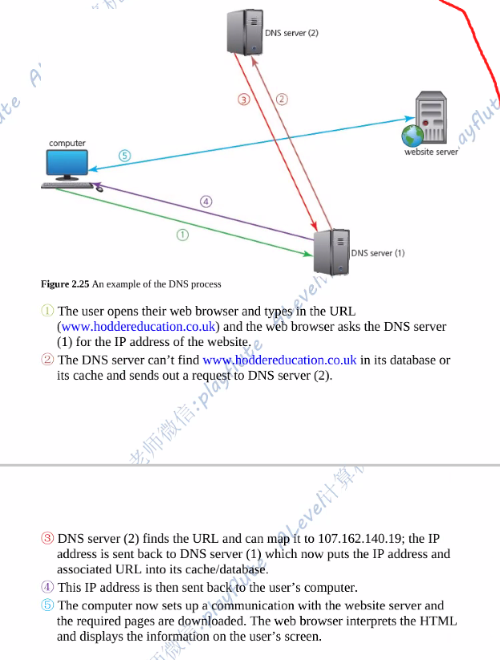

1. client-server model-C/S MODEL
2. Peer to peer model-P2P MODEL

Thin-client--- local-INPUT & OUTPUT-other-REMOTE SERVER

[a client that only provides input and receives output from the application]

Thick-client(NEED TO DOWNLOAD)--- local-MOST

[a client that carries out at least some of the processing itself]

C/S:

ADVANTAGE:

* better performance
* server is always online
* server side has responsibility of data security
* central server looks after the storing

DISADVANTAGE:

* Client and server are not of equal status

P2P:

ADVANTAGE:

* Client and server are of equal status

DISADVANTAGE:

* Offers little data sercurity
* devices take responsibility of data storge themselves
* devices may offonline

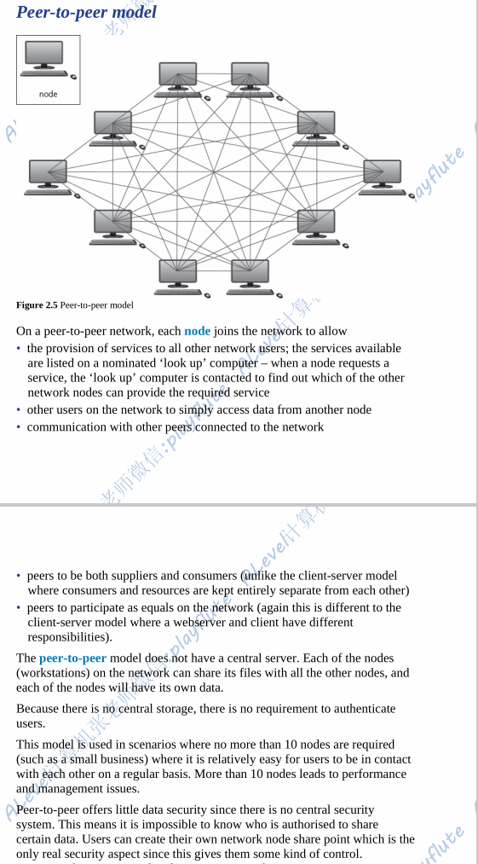

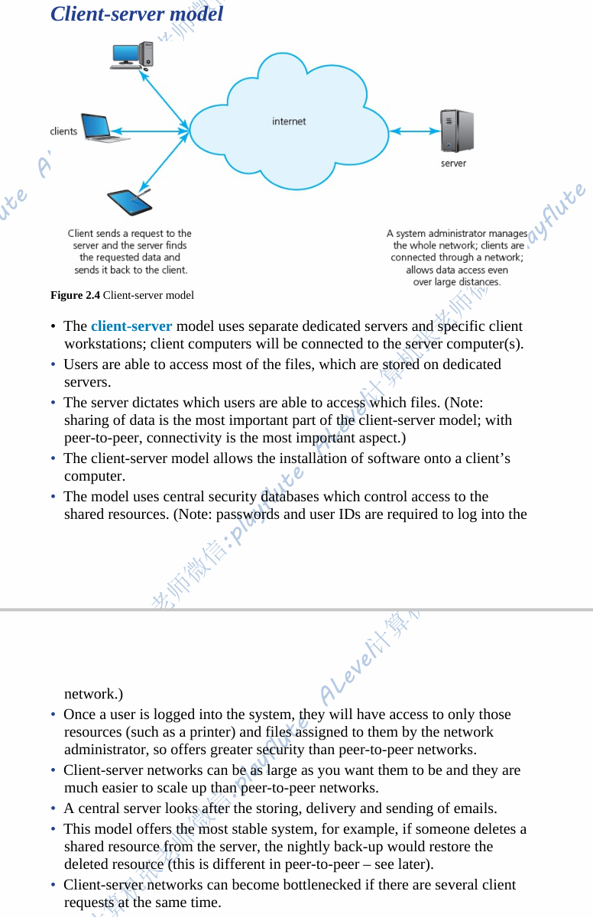

CLOUD COMPUTING

ADVANTAGES

* Cloud storage can be free (for small quantities)
* Saves storage on existing
* Can access data from any computer with internet access
* Most cloud data services will have in-built backup
* Sercurity could be better

DISADVANTAGES

* Can only access with internet access
* Data privacy problem
* Take a long time to upload/download the data
* It can be more expensive in the long term